Scandinavia

1.0 Introduction
The Scandinavian Nation, or to be more precise the Scandinavian and Low Countries Nation is one with up to four separate countries. As designed the main Nation taking 1/3 of each budget plus any leftover is Sweden which historically was the most powerful of these four countries, but any Player may choose which country takes which role. Historically the second country and taking less than or equal to 1/3 of each budget is The Netherlands. The remaining countries are Norway and Denmark, each taking up to 1/6 of each budget. However if a Player was say a Belgian they could replace either Sweden or Netherlands with their country, or any other combination of Northern European countries that the Player desires.

2.0 Options
The Nation has four options, first they must decide whether they are going to use German Using Nations weapons or Prussian Using Nations weapons – all four countries must all use the same weapons. Then they must decide if they are going to select SDr, PB, AC, CA and CL or the Mini ships option. Either way The Netherlands (or The Netherlands replacement), shall select BC, CA and CL, they may not use SDr or AC after the SDr period. All three of the Scandinavian countries must make the same decision. The possible SDr and AC designs are restricted compared with normal ships of this type both in speed and armament regardless of which period they are built in, but all of them will cost half their tonnage.

Any of the four countries may take the restricted SDr and/or AC, in the SDr period, regardless of whether the three Scandinavian countries chose Mini ships or not. All four countries may also take PB from the IT period onwards.

If the Scandinavian countries choose the SDr/PB route then I would suggest that the Nation is probably a Minor one due to lack of speed, if they chose the Mini route, they could well be a Major Nation, though the smaller number of guns on each ship will make it more difficult to obtain hits using my rules.

When building ships in the EW1 and MW1 period, at least 8 mini equivalent ships must be built – a Netherlands BC counts as two mini ships. SDr in later periods weigh less than Mini Ships (they get half tonnage cost), so the 6 mini equivalent ships of the three Scandinavian countries in the EW1 and MW1 is equivalent to 9 SDr. The Norwegian and Danish Navy must each build 2 mini or 3 SDr ships in each of the EW1/MW1 periods and the Swedish Navy must build 4 mini or 6 SDr ships in each of these periods.

3.0 Map
The Netherlands has all three islands on one half of the western chain of islands (either in the northern hemishpere or the southern one but not both). The island nearest the centre of the iris on this line and the island nearest the pole are both 50 miles radius as in the case of the Neutral islands with one port to the north and south of the island. The central island is instead a 100 mile island which is the same as the large Neutral island with four ports and a capital. They have the equivalent of 4/3 rds of a port spread across the eight ports on these three islands as they see fit, except that all the BY(Battleship Yards) and SY(Submarine Yards) are on the 100 mile island. The Netherlands Ports and Capital are larger than a 100 mile island would normally have and smaller than a 200 mile island (the equivalent of an area 1/3 the size of that on a 200 mile island.

Sweden has two 100 mile island with ports (the same size as the Netherlands ports) to the North, South and either East or West as appropriate. These two islands are laid out side by side in an east-west direction, joined by a single port between them. This port has entrances at the north and south and is owned by Sweden, so Sweden has 7 ports and may allocate 4/3rds of the facilities across the 7 ports. To the north and south of the centre of these two islands is one 50 mile island attached to both the larger islands by another port, both of which have entrances to the sea and to the internal sea (a curved trianglur shape between the islands) leading to the port between the 100 mile islands. I would recommend the north 50 mile island is Norway and the island to the south is Denmark. The 50 mile islands have a third port to the north and south respectively and may each spread 2/3rds of a port equivalent across these three ports. The whole structure is 200 miles wide (plus the width of the port) but less than that to the north-south direction. The capital on the western island is for Sweden and the capital on the eastern island is jointly owned by Norway and Denmark.

The railway lines on each island are joined to the next either by high bridges over the port entrances or through a tunnel under the port.

To balance up for the loss of three neutral 50 mile islands the mid island on the eastern chain opposite the Netherlands 100 mile island is also a 100 mile neutral island with a full set of 8 neutral battlewagons, etc as for the other 100 mile island to the far west of the iris.

4.0 Options

4.1 In an All Minor Nation Campaign
If an All Minor Nation Campaign is being run, the Scandinavian Nation with Mini Ships option would be too powerful for the other Minor Nations (it is close to some of the weaker Major Nations), the following changes should be made:
- No BCM are allowed for any country.
- All Danish and Norwegian BBM, CAM and CLM should either mount single mounts of the specified calibre for that era or twins of the next smaller calibre. I would recommend that this was also restricted to AX and that either Q or Y may not be allowed.
- All Danish and Norwegian BBM, CAM and CLM should mount no more than two guns in the casemate or in turrets per side.
- All Danish and Norwegian BBM, CAM and CLM should use the speed for that type in the previous era. In the EDr era they should use the speed for SDr (there are no SDr era Mini Ships).
- An example for MW1 would be BBM=AXSi15 or AXTw12Lo with 2Si150 per side at 21 knots for Norwegian and Danish ships mounting German guns.

5.0 Specifics

5.1 SDr Rules

If the Scandinavian countries opt to use SDr and/or AC in all periods then their speeds and armament are restricted to the values in the table below. PB follow the normal rules. Main guns are shown in the table below.

Swedish and The Netherlands SDr up to the IT period (SDr period only for The Netherlands) may only mount casemates with 3x150mmQF
Norwegian and Danish SDr up to the IT period may only mount casemates with 2x150mmQF
Swedish and the Netherlands AC up to the IT period (SDr period only for The Netherlands) may only mount casemates with 3x105mmQF (note this is not 150mm, it is the smaller 105mm also known as 4.1”).
Norwegian and Danish AC up to the IT period may only mount casemates with 2x105mmQF (note this is not 150mm, it is the smaller 105mm also known as 4.1”).
From the IT period onwards these casemates may be replaced with by the same number of turrets mounting a Si150mmQF or a Tw105mm of any type.
All three countries may build standard PB from the IT period onwards and Sweden may build any number of CLG from start of the LIT period onwards regardless of the decision to take SDr and AC or not.
With this option, PB and CL may be built in the EIT period and CA and CL in the LIT and PLT period.
If desired, SDr can be built with Cruiser budgets in the IT period as well as AC and any of the other cruiser types.

5.2 Mini Ship Rules
If the Scandinavian countries opt to use Mini Ships then they may only build BBM, BCM, PB, CAM and CLM from the EDr period onwards. The only exceptions are (the following are full sized ships):
- any of the German or Prussian CA1 can be built using the CA1 budget
- any of the German or Prussian CL1 can be built using the CL1 budget
- Sweden and The Netherlands may each build one CAA in the PLT period, though they may independently opt to replace it with two CLA XXXX max guns (ie they can have 2xCAA, 1xCAA+2xCLA or 4xCLA between them)
- Norway and Denmark may each build one CLA in the PLT period
- The Netherlands can only build full sized ships, but the cruisers are restricted (see below) and cannot build SDr or AC after the SDr period. Their BC are the same as the BC for either Germany or Prussia (whichever set of weapons are selected), though a 3Tr layout can also be used from the EW1 era onwards using the appropriate calibre (not 16” until PLT onwards though, only Tw16 may be mounted in the LW1 era, and lighter guns in the LIT era).
- Sweden can build CLG in the LIT period as well as or instead of CLM.

All BBM, BCM may have up to 3xSi150mm in casemates or later turrets per side.
All CAM, CLM may have up to 3xSi105mm in casemates or later turrets per side. During the the W1 period one of these may be an AA weapon, in the IT and later periods all of them may be AA weapons and once DP mouts have been designed all of them may be DP.

Note there is a “V” gun layout (5 guns) for the Mini Ships where an optional fifth main gun is mounted as a single in either Q position or Y position. If the Y position is used for this position then an extra AA mount cannot be added in the PLT period at the rear of the ship (B turret may still be added in this case). PLT BBM and BCM may add a Tw105AA in both B and Y (assuming Y is not already occupied) and CAM and CLM may add a Si105AA in these positions.

In the LW1 period only 16 guns of either 16” or 15Lo may be mounted in total, leaving the remaining ships with up to five guns of either 15” or 14Lo using the “V” rules above. CAM and CLM mounting German guns may also use the “V” rules as described in the table below.

To calculate the tonnage of AAA for these Mini ships, multiply the tonnage of the ship by two and halve the weight of allowable tonnage of AAA.

5.3 The Netherlands

Regardless of the Scandinavian decision to build SDr or Mini Ships, The Netherlands may only build BC with the Battlewagon budgets and PB, CA or CL with the Cruiser budgets. The Battlecruisers will be the same as the German or Prussian Using Nations of the same period. If they build the restricted cruiser designs laid out below then they may build the ships with three knots more than the standard cruiser speed for German or Prussian Using Nations. They may build the cruisers to the equivalent designs for German or Prussian Using Nations but do not get the option to add 3 knots to that design.

From the LW1 period onwards, The Netherlands may also build BC with 3Tr mounts of the appropriate gun but not the 16”/15Lo calibre in the LW1 period. It is recommended that the third mount be in Y rather than B.

In the PLT period The Netherlands may build Sph with AYXTw150 and 2Si9pdrAA per side plus AAA and also Ten150 though neither are eligible for the 3 knots extra speed.

The restricted cruiser designs that can add an extra 3 knots are all seven gun ships with Twins in AYX and a Single in B. CA would carry 7.5QF and CL would carry 150mm.

5.4 Destroyers

The destroyers for all countries are as the German or Prussian Using Nations standard designs, or actual destroyers built by that country in that era. Each country should have the appropriate portion of the total number of divisions/squadrons – note do not assign part of a division or squadrons to a country. Exception – there may be one division with two Danish destroyers and two Norwegian destroyers.

Apart from DAAHS described elsewhere, this Nations mothballed destroyers can be modified to any of the designs in the German or Prussian Using Nations as appropriate. During the war if WVL are built then an extra DAAHS can be modified for each.

5.5 Carriers
Sweden and The Netherlands each have 1EVF, 1EVL, 1LVF, 1LVL and 1PVL
Norway and Denmark each have 1EVF, 1LVF and 1PVL
XXXX check that this is the correct number of carriers
In addition if the Scandinavian countries choose to use SDr then add an extra two EVL to the fleet – these can be assigned to any of the four countries.

Due to the fact that there are more VL in this Nation than normal (to allow a reasonable balance across the four countries) there are less AA guns than normal on the carriers. To make up for this add 6 DAAHS as described elsewhere to the fleet – one should be assigned as a permanent AA protector to each of six of the EVL or LVL (players choice as to which these they are assigned to). The extra two EVL do not get an extra DAAHS as described here nor do the PVL.

5.6 Submarines

This Nation only has standard submarines as described elsewhere, split them up into the specified ratios, after the start of the war special submarines may be built, and thy have access to German/Prussian special submarines at the appropriate time.

6 Completion
Because of the size of these vessels, those SDr, AC and Mini Ships will complete in pairs. Where the rules state that one Battlewagon or Cruiser will complete, in this case two will complete. A slip for example will be the standard size and two ships built on the same slip one behind the other. Completion Docks and Dry Docks will also be the same size as normal allowing two ships to complete in each at the same time. Other full sized ships such as BC, CAA, CLA, VL, CLG, Destroyers etc will complete singly and in the normal way.

The two lightest Dutch BC and one PB may be completed during the LIT period (the BC are a LIT design and the PB is a PLT design). Treat the rest of the Dutch BC as if they were BB for completion purposes. Similarly if there are any BCM not completed in the PLT period then treat each pair of BCM as a BB for completion purposes.

7 Centralised Fire Control
A CFC/RFC system can never be developed by this Nation.

8 Table

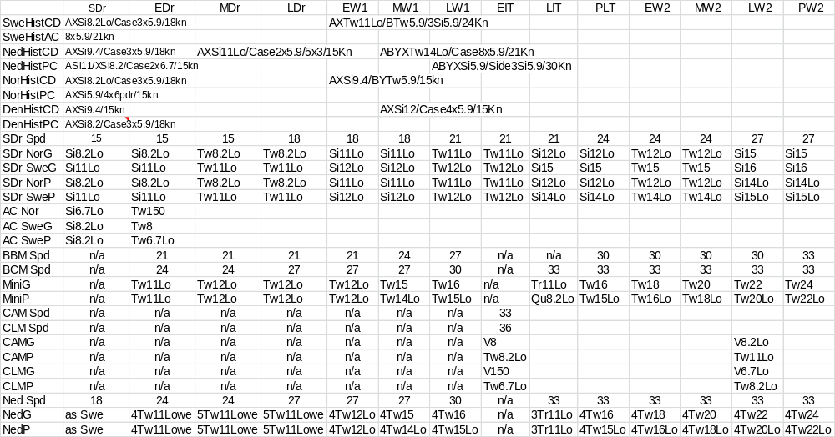

Some of the designs above are marked with a “V”, these allow for a fifth gun on the design. The extra Single may be mounted either in the Q position (between the Bridge and rearmost funnel) or superposed in the Y position though note that if it is mounted in Y then the optional Y secondary armament cannot be mounted there from the PLT period onwards.

Notes:
Remember you can always use an older design or lighter calibre
If using German guns in AC after LW1 then replace Tw6.7Lo with Tw8
If using SDr/AC then can build PB&CL in EIT and CA&CL in LIT, SDr and AC can be built with Cruiser Budgets in the IT period, Mini ships cannot be built in any period
If using BBM/BCM then Scandinavians can only build PB, CAM, CLM from the EIT period and CAA (not mini) in PLT onwards
Sweden can always build CLG in the LIT XXXX period onwards regardless of what other decisions are made
In PLT for Mini ships add B (and Y if not already used) which may be Si150 or Tw105 of any appropriate type, eg DP when it is available
AC Nor casemates are 3x105QF
AC Swe casemates are 3x150QF
SDr Nor casemates are 2x150QF
SDr Swe casemates are 3x150QF
Casemates are replaced with turrets/shields in the EIT period onwards any of which may be Tw105AA
The Netherlands may build CA as standard but may restrict them to a max of 7x7.5QF (BSi, AYXTw), CL may be 7x150 in the same layout
Ships using these restricted armaments (in the line above) may be built with an extra 3 knots, and PLT onwards may be SPh with AYXTw150 with 2Si9pdrAA per side and AAA as per its weight
The Netherlands may also build Ten150 in the PLT period
Sweden and The Netherlands may each build one CAA in the PLT period but can replace it by 2xCLA
Norway and Denmark may build one CLA each in the PLT period
"V" armament is AXTw with an optional Si in either Q or Y, note if Y is used an extra turret cannot be added in the PLT at the rear
"V" armament can only be used on all CAM/CLM
"V" armament can by used on Swedish BBM in the second era that the same calibre is used in and third era that Norway/Denmark use the same calibre
So Sweden could have a V16 in EW2 and Denmark/|Norway in MW2
In LW1 period only 16 guns of 16" or 15Lo may be mounted, other ships built in this period may mount 5 guns of the next lower calibre using the "V" rules
The Historical designs are to show what was actually built

